April 2016

LIFETIME PRODUCTIVITY. For the manufacturing tasks of today and tomorrow.
Investing in a HELLER machining centre means investing in the future: smaller batch sizes, shorter delivery times and growing component complexity require continual optimisation and streamlining of the manufacturing process. In response to these requirements, HELLER is offering Lifetime Productivity: our machines aim to meet not only current needs but also provide the capability to be used flexibly, efficiently and productively throughout their entire life cycle. By adding specific technology and application know-how, a standard machining centre can be transformed into a powerful, sustainable asset for efficient complete machining – always with the goal to support our customers in mastering their production tasks and helping them to successfully compete in the market.
Agenda

- At a glance: facts and figures
- 2015 review: HELLER with strong balance sheet
- 2016 outlook: positive trend
- Awards I: consistent and sustained personnel development
- Awards II: 2015 Daimler Supplier Award
- Organisation: expansion of the HELLER management board
- In focus: Industry 4.0

Press relations
Gebr. Heller Maschinenfabrik GmbH

Marketing
Marcus Kurringer
Gebrüder-Heller-Straße 15
72622 Nürtingen
Germany
Phone: +49 7022 77-5683
Fax: +49 7022 77-165683
marcus.kurringer@heller.biz

At a glance: facts and figures
- 2015 order intake
  - EUR 561.4m (2014: EUR 558.1m)
    - 55% Europe (2014: 69%)
    - 19% North and South America (2014: 23%)
    - 26% Asia (2014: 8%)
- 2015 turnover
  - EUR 555.9m (2014: EUR 434.4m)
- 2015 total operating revenue
  - EUR 561.4m (2014: EUR 462.5m)
- Equity capital 2014
  - EUR 111.4m
  - Equity ratio: 33.8% (2014: 34.5%)
- 2015 investment volume
  - EUR 11m
- 2015 development expenditure
  - EUR 14m
- 2015 workforce
  - HELLER Group worldwide: 2,534 (including apprentices)
  - HELLER in Germany: 1,970 (including apprentices)
2015 review: HELLER with strong balance sheet
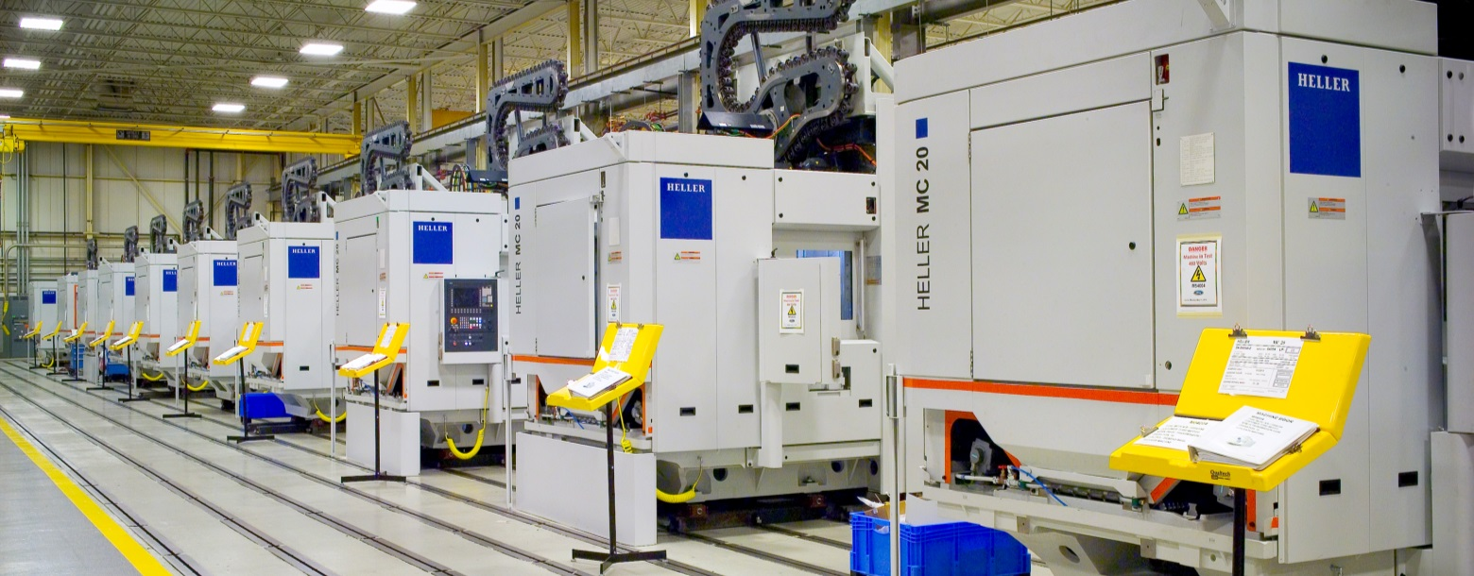
In 2015, the HELLER Group had a turnover of EUR 555.9m, representing a significant increase of 28% over the previous year. Sustained high capacity utilisation meant that in particular the facilities in Nürtingen were partly operating at their capacity limit. Order intake and orders booked maintained the high levels of the previous year. Good results are also expected for 2016.
Order intake: second highest in the history of HELLER
2015 order intake reached EUR 561.4m, thus exceeding the strong previous-year figure by approx. 1%. It confirms the positive development noted in 2014 and resulted in the second highest order intake in the history of the HELLER Group. Results of all business divisions have approximately reached the levels of the previous year. Project business, especially with automotive customers, still accounts for more than 50% of our business volume.
Origin of orders: increasing volumes from China
The development at our Chinese customers significantly contributed to achieving the high order volume. Clearly increasing order volumes from China have compensated for the expected decline in business from Europe, accordingly resulting in geographic shifts in the distribution of order intake. Nevertheless, Europe (including Germany) still holds the strongest share of 55% (previous year 69%); Asia has seen a relatively strong increase to 26% (previous year 8%), whilst North and South America together make up for 19% (previous year 23%).
Turnover and total operating revenue: outstanding project business in Europe, the US and Asia
At EUR 555.9m, the turnover achieved in 2015 was EUR 121.5m (+28%) above the previous year. Due to better than expected development of project business in Europe, the US and Asia, our optimistic planning assumptions have been clearly exceeded. Increase in inventories and capitalised services included, the total operating revenue amounted to EUR 561.4m (previous year: EUR 462.5m), which is far above average in multi-year comparison.
Result and capital resources: stable conditions
Due to the increase in volume, the result from ordinary business activities significantly increased year-on-year. As per the end of the year, the group's equity capital increased further to EUR 111.4m (previous year: EUR 108.8m). At 33.8%, the strong equity ratio almost remains unchanged. All in all, the financial and assets position provides a very sound basis.
Investments and developments
Investments in 2015, totalling approx. EUR 11m, included real estates and buildings as well as operating and business equipment. Apart from measures aimed at preserving capacity and improving efficiency, investments were made in future optimisations of warehousing and logistics.
New product development and product refinement as well as additions to our portfolio of machines remained focal points in the past fiscal year. Investments in internal development measures totalled EUR 14.0m in 2015. That means our development expenses were approximately at the previous year's level.
The focus was on continuing the development of a new machine type started the previous year, targeted expansion of our product portfolio in terms of machines for 5-axis and combined machining, development of our own user interface with integrated functionalities and cost optimisations on existing high-volume machines from the H and MC series.
Healthy growth within the HELLER Group
As per the end of the year, the number of employees, including apprentices, increased from 2,466 to 2,534. This figure mainly reflects a moderate increase in staff at the Nürtingen location in order to adapt capacities to the increasing total operating revenue.
Professional education of young people as skilled workers continues to have high priority. Additionally, we are offering a number of work-study programmes. To keep our staff's knowledge and skill levels up to date, we provide numerous training, qualification and further education measures. They are based on uniform international qualification standards and HELLER's group-wide educational standards.

2016 outlook: positive trend continues
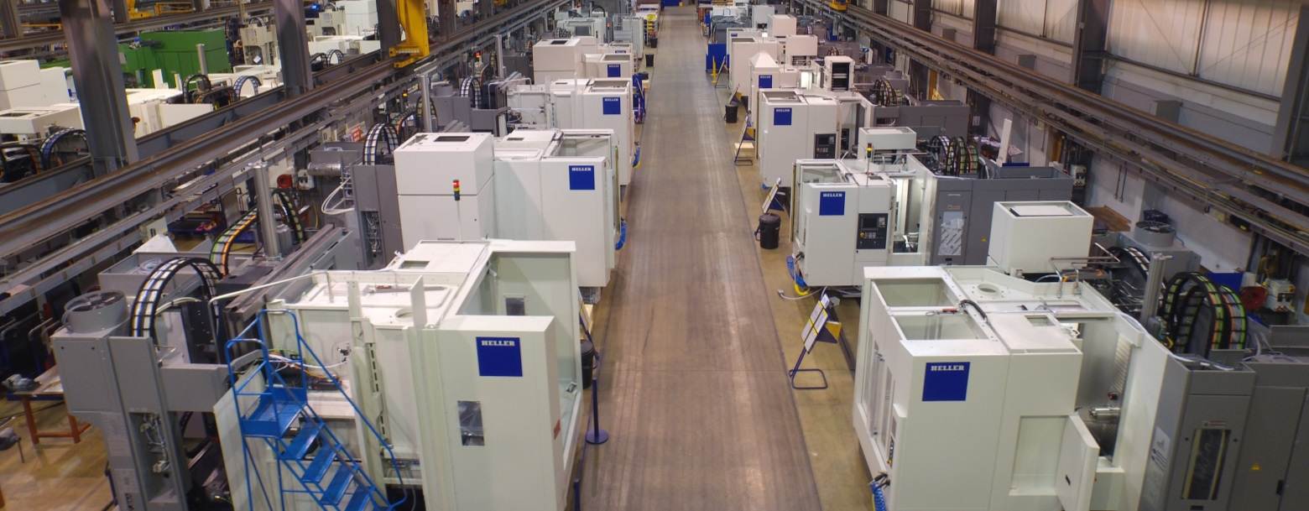
2016 forecasts for the global economic situation and the general business situation in our industry are cautiously optimistic. We also expect most of our relevant submarkets to develop positively. Domestic machine tool production is expected to see another slight increase, thus reaching a new record level.
With an order balance of EUR 385.2m, we are starting the year 2016 with satisfactory basic utilisation. Based on the current order book and further orders to be expected, we assume that the year 2016 will again be noticeably above EUR 500m in terms of turnover and total operating revenue with a further improvement of the profit situation.
The reasons for this are the sales gained from the orders on hand and winning further lucrative orders for project and stand-alone machines due to generally upbeat forecasts for the business situation in our industry. In 2016, we will continue further development of our sales and service strategy and the systematic development of selected target markets providing interesting market potential. Our current product portfolio provides further opportunities for positive development this year. New machine types help to attract new customers and industries and to open new fields of application. The optimisation of manufacturing and cost structures, both at individual locations and within HELLER's global value-creation network, as well as our global presence form the foundations for systematic customer orientation.
All in all, we believe that the HELLER Group is well-positioned in terms of markets and products with a strong order situation today. As a result, we are expecting a gratifying development of business throughout 2016, also in terms of earnings.

Awards I: consistent and sustained personnel development rewarded
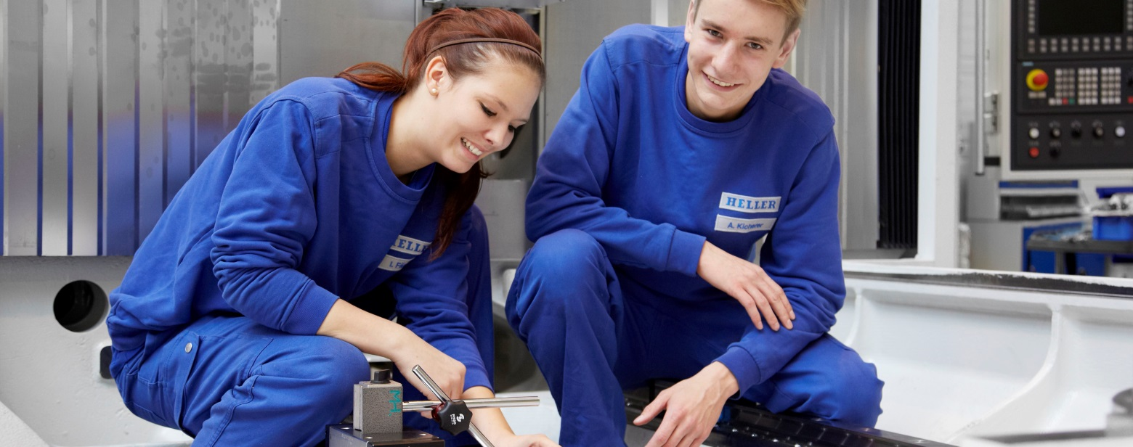
Training and personnel development at HELLER are key to tomorrow's success. That is why the company is proud that, throughout the world, the name HELLER has for a long time been synonymous with excellent products and services as well as outstanding, renowned and sophisticated vocational education and advanced training – at all production locations. For its long-term personnel development and welfare HELLER received three awards in the first quarter of 2016.
Federal Employment Office honours HELLER with Education Certificate
For its exceptional commitment in the field of education and training, HELLER received the Education Certificate of the Federal Employment Office of Germany. Training rate, creation of additional apprenticeship training positions, above-average social commitment and the quality of the training were the criteria for awarding this certificate. Social commitment of apprentices in particular was lauded as exceptional. There are many reasons why apprentices enjoy working at HELLER so much. The positive working atmosphere between training supervisors and trainees, varied projects and challenging tasks under optimal working conditions in an excellently equipped training department are among the arguments mentioned by the young people.

HELLER receives award as “Exemplary Disability Friendly Employer”
The Kommunalverband Jugend und Soziales (KVJS) Baden-Württemberg (Municipal Association for Youth and Social Affairs in Baden-Württemberg) has honoured our company as an “Exemplary Disability Friendly Employer”. HELLER convinced the jury with its continuous commitment to people with disabilities. At HELLER, disability friendly means providing people with disabilities tailored workplaces. The company also does everything to retain employees suffering from prolonged illness. This is aided by the good and trusting cooperation with the disabled employees' representative. Last but not least, the jury was convinced that the integration of people with disabilities forms part of HELLER's corporate culture.
HELLER counts among the best employers in Germany
In cooperation with XING and the Kununu rating portal, news magazine FOCUS conducted a survey among the employees of more than 2,000 companies using an online access panel to find Germany's “Best Employer”. The results have now been published in a special edition of FOCUS magazine. In the overall ranking, HELLER holds the 108th position and in the “Machinery and Plant Engineering” industry ranking an excellent 7th place. Among the metal-cutting machine tool builders the company even succeeded in taking the top spot. This award is proof that as an internationally operating company we are setting the right priorities with long-term personnel development and welfare. Until today, HELLER is synonymous with attractive employment opportunities and a system of social values, giving equal consideration to business objectives and staff interests, ensuring that both are in balance.

Awards II: 2015 Daimler Supplier Award
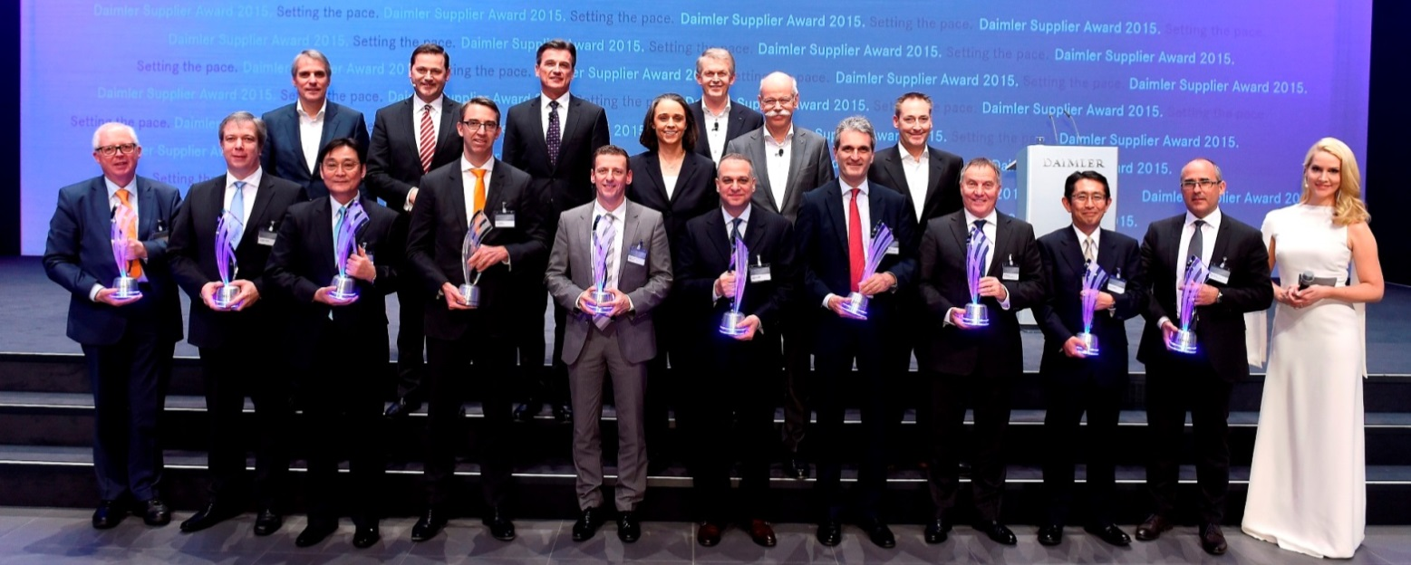
HELLER has received the 2015 Daimler Supplier Award in the category “International Procurement Services” for supporting the automotive manufacturer in the further development and industrialisation of the innovative Nanoslide® process for the coating of cylinder bore surfaces of aluminium crankcases.
As a manufacturer of machine tools and complete manufacturing systems, HELLER industrialised all steps of the coating process under the name HELLER CBC (CylinderBoreCoating), developing it into a dependable technology for global application in series production. HELLER not only integrates the process, including the process steps for pre- and finish-machining, into the process chain in engine production, but also guarantees a correspondingly high level of process quality and reliability. By now, numerous systems have been installed successfully in Germany and Japan. International OEMs at more than 20 locations worldwide are planning to implement the new process technology in the coming years. Daimler AG has honoured 10 suppliers for their outstanding performance in the past financial year with the 2015 Daimler Supplier Award. In front of an audience of around 450 invited guests from the supplier industry, the coveted prizes in the categories of Quality, Partnership and Innovation were awarded in February 2016 at the Mercedes-Benz Branch in Stuttgart for the eighth time.
Organisation: expansion of the HELLER Management Board
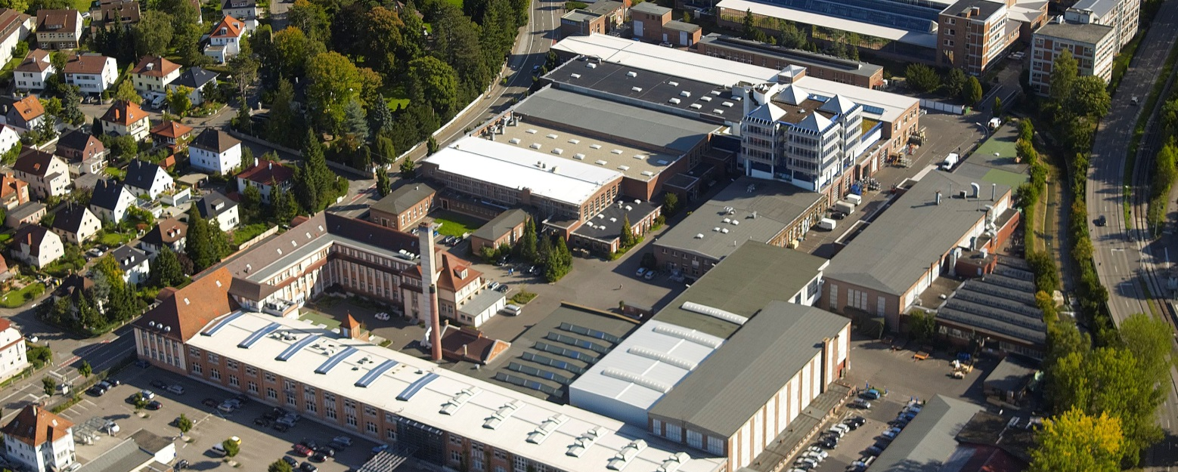
As of 1 February 2016, the existing Management Board of Gebr. Heller Maschinenfabrik GmbH in Nürtingen with Klaus Winkler and Manfred Maier will be joined by three new Managing Directors. With this decision, HELLER continues to place the emphasis on continuity and professional competence in the leadership of the company.
In the Management Board, Dieter Drechsler will be responsible for Projects & Applications. He will be coordinating the tasks of global sales and project business, ensuring that the key suppliers of production solutions in the global market are aware of HELLER and interested in buying its products.
As the Managing Director of Operations, Patrick Rimlinger will be responsible for securing and optimising the global production and procurement network. In recent years, he successfully coordinated the foundation and development of the company’s Chinese production facilities in Changzhou and optimised global processes in Production and Supply Chain Management.
From February onwards, Dr. Jürgen Walz will be responsible for Development as a Managing Director. He will be concentrating on new and further development of the current machine range and the evaluation and implementation of new technologies and processes.
Managing Directors Klaus Winkler and Manfred Maier will continue to plan and actively support the further strategic development of the entire HELLER Group. Thus, HELLER will remain a reliable partner, combining cosmopolitanism and global market presence with the flexibility, stability and financial soundness of a family-owned business.

In focus: Industry 4.0
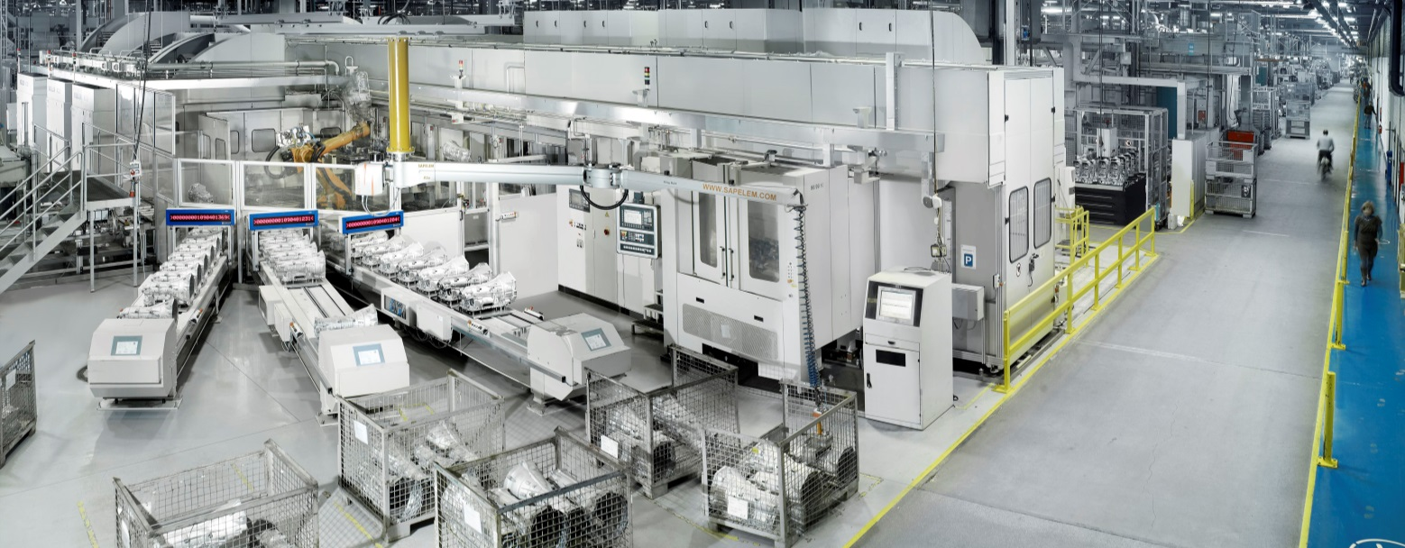
The “Industry 4.0” approach is the (r)evolutionary summary of what we as a globally active machine tool manufacturer have been experiencing to some extent for some time now. The idea of “Cyber-Physical Systems” (CPS) is only the resulting consequence for the future. The machine tool, forming a part of these CPS, is probably the one element best prepared for this future. The greater challenges will be the harmonisation of interfaces of the various systems and the people involved.
In terms of Industry 4.0, HELLER is focusing on further increasing machine productivity and on supporting consistent value-added chains from the digital to the real world. Core aspects are supplementary machine functions, on-demand services and enhanced service capabilities. Essential for this are new industry standards in terms of data exchange and data security as well as standardised interfaces. HELLER is accelerating the evaluation of existing machine sensors and supports network integration of the machines, using services on network computers.

HELLER AT A GLANCE
Founded in: 1894 in Nürtingen
2015 workforce: 2530
2015 order intake: EUR 561m
2015 turnover: EUR 556m
Chairman of the Board: Berndt Heller
Managing Directors of the HELLER Group: Klaus Winkler, CEO
Manfred Maier, COO
Dieter Drechsler, Projects & Applications
Patrick Rimlinger, Operations
Dr. Jürgen Walz, Development
Regional Managing Directors: Christian Pfleiderer, HELLER Europa Sales & Services
Andrew Parkin, HELLER Asia
Keith Vandenkieboom, HELLER North America
Alfredo Griesinger, HELLER South America
Fields of business: 4-axis and 5-axis machining centres
Mill/turning centres
Flexible manufacturing systems
Machines for crankshaft and camshaft machining, CBC systems
Services
Production locations: Germany (Nürtingen)
United Kingdom (Reddich)
USA (Troy/Michigan)
Brazil (Sorocaba)
China (Changzhou)
Sales/Service locations: EUROPE
Germany (Hattingen, Salem, Goslar, Saarbrücken, Nuremberg, Nürtingen)
Italy (Verona) France (Paris)
Poland (Posen) Spain (Barcelona)
Sweden (Värnamo)
Switzerland (Niederbüren)
Slovakia (Vráble)
Russia (Moscow)
NORTH/SOUTH AMERICA
Mexico (Querétaro) Brazil (Belo Horizonte, Gravataí, Joinville)
ASIA
China (Beijing, Chongqing, Shanghai)
India (Pune)
Thailand (Bangkok)
Singapore

